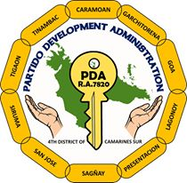
Republic of thePhilippines
PARTIDO DEVELOPMENT ADMINISTRATION
Created Under R.A. 7820
Tigaon, Camarines Sur
____________ , 20 _____

PRICE QUOTATION

______________________
______________________

Sir/Madam:

Please quote your prices of the following articles which this office desire to purchase for use in internal quality audit training (Nov. 7-9, 2017).

ITEM # | PARTICULARS | QTY. | UNIT | UNIT COST | TOTAL  COST
1  2  3 | Nov. 7, 2017  Room Accommodation (ISO Consultant)  Nov. 8-9, 2017  Banquet Package for 28 pax for 2 days  Room Accommodation  8 rooms for 2 days | 1  1  1 | Pack  Pack  Pack

Dealer: ______________________________________
TIN: VAT#: ______________________________________ NON-VAT#:_____________________
Address: ______________________________________
Telephone No.: ______________________________________
Contact Person: ______________________________________
Canvasser: ______________________________________

Sir/Madam:

I have the honor to offer my prices for each of the above articles as indicated after each item hereon.

Very truly yours

______________________

